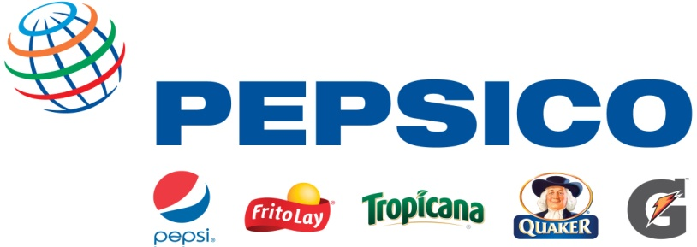

Job Title: R&D Packaging Intern

Why PepsiCo?
PepsiCo offers the world's largest portfolio of billion-dollar food and beverage brands, including 22 different product lines that generate more than $1 billion in annual retail sales each. Our main businesses -- Quaker, Tropicana, Gatorade, Frito-Lay, and Pepsi Cola – also make hundreds of other enjoyable foods and beverages that are respected household names throughout the world. With net revenues of approximately $65 billion, PepsiCo's people are united by our unique commitment to sustainable growth by investing in a healthier future for people and our planet, which we believe also means a more successful future for PepsiCo. We call this commitment Performance with Purpose: PepsiCo's promise to provide a wide range of foods and beverages for local tastes; to find innovative ways to minimize our impact on the environment, including conserving energy and water usage, and reducing packaging volume; to provide a great workplace for our associates; and to respect, support and invest in the local communities where we operate.

Functional Description:
R&D Packaging Engineering Interns at PepsiCo translate strategic market objectives into new packages and processes/equipment. Our Engineers participate in and lead accelerated packaging development life cycles that include new idea generation, prototype development, packaging optimization, process/equipment development, process/equipment scale-up, and production start-up for test market and national launching of new products.

What you can expect:
- Utilize scientific methods to develop knowledge that creates business opportunities that support the company strategic market objectives
- Provide technical and business risk assessment/perspectives related to new packaging development
- Design and execute experiments, and analyze and interpret data to make sound technical recommendations on packaging and process/equipment issues
- Initiate innovation and development of new technology to maintain and grow the PepsiCo business
- Leverage external and internal experts for key analytical and sensory research
- Participate as an active member of cross-functional business development teams comprised of individuals from a variety of disciplines, including Marketing, Purchasing, Engineering and other groups
- Participate in quality/packaging improvement and productivity initiatives
What we’re looking for:
- Currently pursuing Engineering Degree with a focus or interest in packaging (Chemical/Mechanical/Electrical/Material)
- Must graduate with final degree (Bachelor’s and/or Master’s) within one (1) year of internship completion
- Demonstrated ability to translate business objectives into strategic and tactical project goals and objectives
- Proven ability to make significant technical scientific advances utilizing internal and/or external resources
- Demonstrated understanding of how to incorporate business needs into technical decisions
- The ability and interest to work in laboratory, pilot plant and manufacturing scale environments
- Proven ability to manage multiple assignments/ tasks
- Strong communication skills (oral and written)
- Willingness to travel up to 10%
- Actual working location will be Plano, TX

Minimum Qualifications:
- Candidates should be completing their junior year of studies
- Eligible to work in United States without work authorization sponsorship
- Must pass a drug screen and background investigation

EEO Guidelines:
PepsiCo is an equal opportunity employer and gives consideration for employment to qualified applicants without regard to race, color, religion, sex, national origin, disability or protected veteran status.
If you’d like more information about your EEO rights as an applicant under the law, please download the available EEO is the Law (http://pep.jobs/eeo-poster) & EEO is the Law Supplement (http://pep.jobs/eeo-poster-supplement) documents by copying and pasting the appropriate URL in the address bar of your web browser.
How to apply:
To be considered for an interview, you must submit your resume with the career center and complete an online application on our website.

To apply for the position on our website, please follow the instructions at the link below:

https://jobs.brassring.com/1033/ASP/TG/cim_jobdetail.asp?partnerid=25331&siteid=5105&Areq=85533BR

